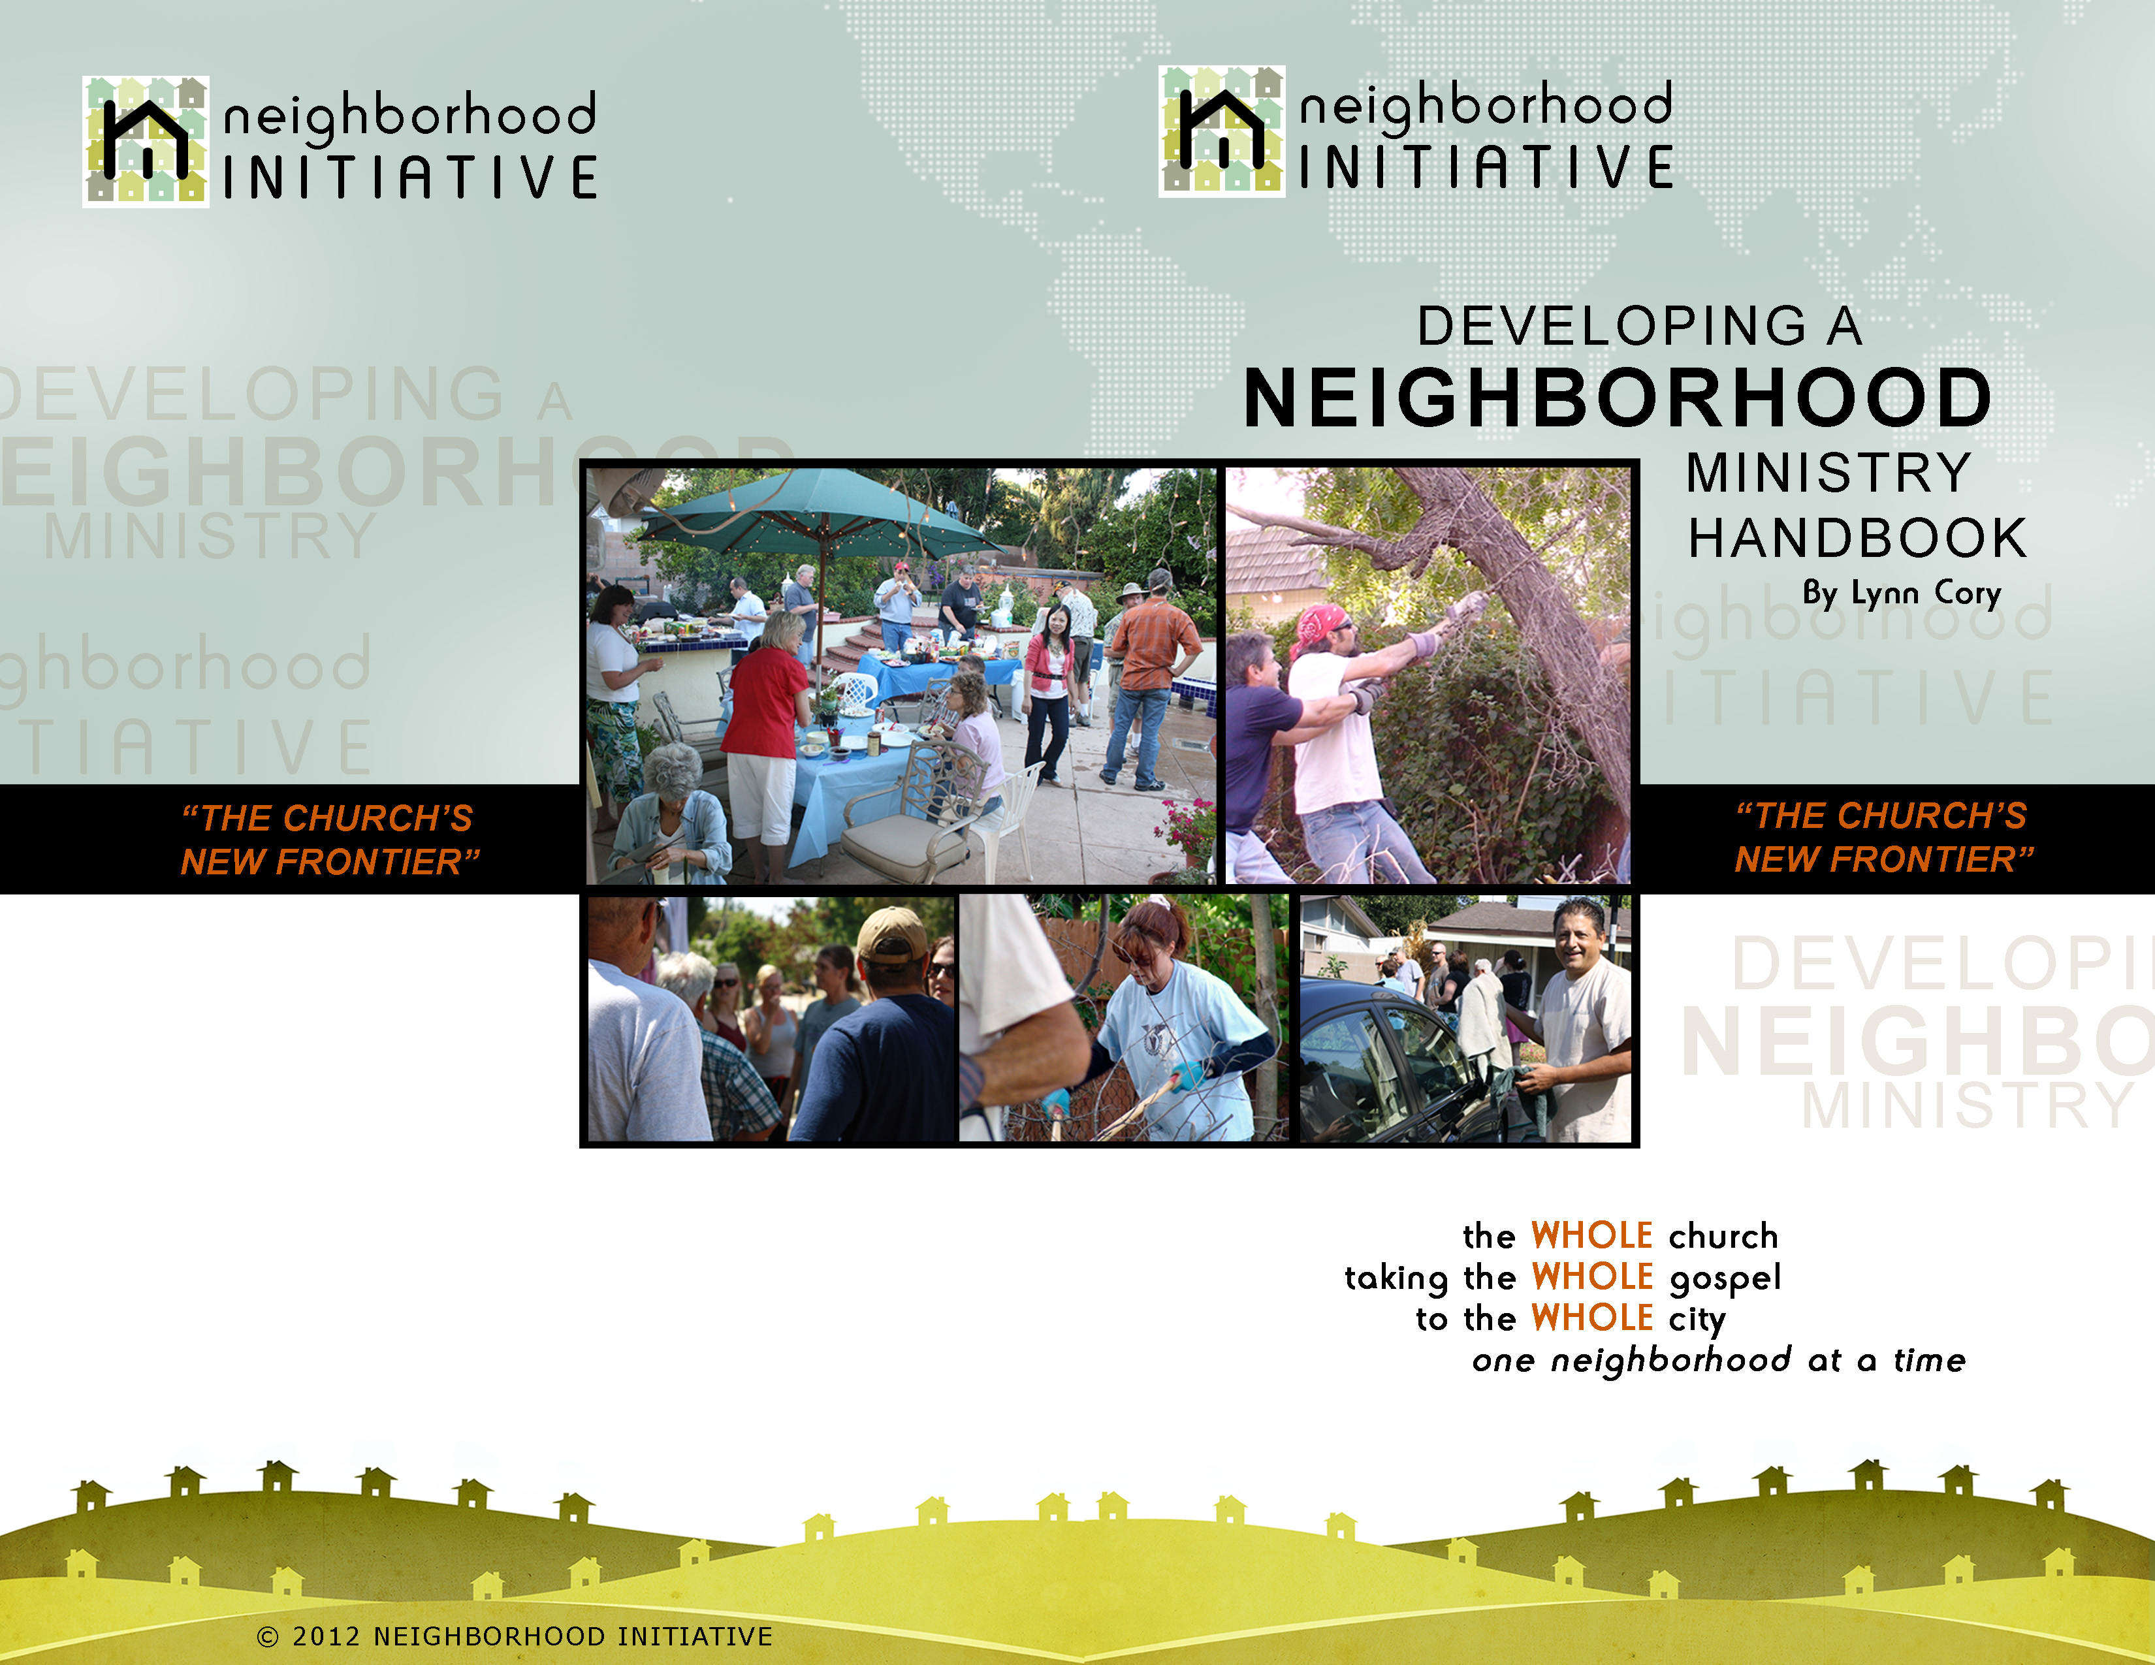

**Introduction**

Developing a “Neighborhood Ministry” is a process. Remember, “little by little” God’s kingdom grows and penetrates the world. The parables of the mustard seed and the yeast help us understand this process. "The kingdom of heaven is like a mustard seed, which a man took and planted in his field. Though it is the smallest of all your seeds, yet when it grows, it is the largest of garden plants and becomes a tree, so that the birds of the air come and perch in its branches." He told them still another parable: "The kingdom of heaven is like yeast that a woman took and mixed into a large amount of flour until it worked all through the dough." Matthew 13:31-33 (NIV) In the same way, ministry in your neighborhood starts with small acts of kindness and service which grows into what God has in mind for it. Like the leaven (yeast), it only takes small expressions of love to transform your neighborhood.

In the first section you will find the overall plan for Neighborhood Ministry and in the second section are listed some simple steps to start a Neighborhood Ministry. Also you will find in the last section a resource of ideas for ministering in your neighborhood. Interpolate for an apartment complex or another setting.

**1. OVERALL PLAN FOR NEIGHBORHOOD MINISTRY**

**Getting Started:**

**Be Intentional.** Establishing ministry in your neighborhood is more than a good idea or something you are involved with occasionally; it is a **commitment** to *“Love your neighbor as yourself.”* There is a marked difference between being a nice neighbor and doing things for them when you have the time and having a deep concern for their welfare and acting on it. Consider how you have taken care of yourself over the years and now love your neighbor in the same manner. It will make a profound change in your neighborhood.

**Connect to the Local Church.** Involvement in ministry always requires coming under leadership. It is in this context that God gives favor, direction, protection, and blessing to what He wants to do through you. Let the leadership of your church know of your intention to start a ministry in your neighborhood. You can come under a covering by meeting with one of the leaders on an ongoing basis, or by participating in another community group where prayer support is available to you.

Neighborhood Initiative Page 1

© 2012 NEIGHBORHOOD INITIATIVE

Borrow items from your neighbors or volunteer to help them with a project.

Canning Hunger (Door-to-Door Food Drive - see resources)

Car Wash & BBQ

Christmas Caroling

Christmas: Put up lights for neighbors. Include the neighbors in helping neighbors.

Free Car Wash for the neighborhood (You might want to add free BBQ hotdogs & drinks while your neighbors wait.)

Help with funeral reception.

Meal Sign-up: Take care of a neighbor after a death or in case of a hospital stay.

Movie Night or Outdoor Movie Night: Project a movie onto a garage or outdoor screen.

Neighborhood Co-Op: Coupons, Babysitting, Help with Taxes, Window Washing, Serve at their party so they can enjoy their guests.

Neighborhood Garage Sale

Neighborhood newspaper: Ask neighbors for submissions.

Further Reading

Joseph C Aldrich. Gentle Persuasion. Portland: Multnomah, 1988.

Joseph C Aldrich. Life-Style Evangelism. Portland: Multnomah, 1981.

Robert E Coleman. The Master Plan of Evangelism. Grand Rapids: Spire, 1994.

Randy Frazee. The Connecting Church. Grand Rapids: Zondervan, 2001.

Randy Frazee. Making Room for Life. Grand Rapids: Zondervan, 2003.

Ted Haggard. Primary Purpose—Making it Hard for People To Go to Hell from Your City. Lake Mary: Creation House, 1995.

Robert Lewis. The Church of Irresistible Influence. Grand Rapids: Zondervan, 2001.

Jay Pathak and Dave Runyon. The Art of Neighborhing, Baker Books 2012

Alan J. Roxburgh. Missional; Joining God’s Church in the Neighborhood. Baker Books 2011

Steve Sjogren. Conspiracy of Kindness. Ann Arbor: Vine Books, 1993.

Steve Sjogren and Dave Ping. Outflow. Loveland: Group, 2006.

Rodney Stark. The Rise of Christianity. New York: Harper One, 1996.

Richard Stearns. The Hole in Our Gospel. Nashville: Thomas Nelson, 2010

Rick Rusaw and Eric Swanson. The Externally Focused Church. Loveland: Group, 2004.

Eric Swanson and Sam Williams. To Transform a City. Grand Rapids: Zondervan, 2010

Neighborhood Initiative Page 12

© 2012 NEIGHBORHOOD INITIATIVE

Create a library of books for kids.

Group gardening classes – celebrate with a big salad.

Marriage or Classes

Neighborhood newspaper: Ask neighbors for submissions. (Children can get involved in this.)

Photography lesson during a neighborhood walk.

Scrapbooking or other craft class

Start a Book Club.

Start a library checkout.

Story reading for children in the neighborhood

**Fun ideas neighbors can do together**

“Sunday Sundae”- Neighbors gather for sundaes on Sunday.

4th of July Parade: Decorate bikes, wagons, pets for a parade.

Block Party

Car Wash & BBQ

Christmas Caroling

Christmas: Put up lights for neighbors. Include the neighbors in helping neighbors.

Host a Pancake Breakfast in the front yard if possible to let neighbors see what is going on.

Movie Night or outdoor movie night: Project a movie onto a garage or outdoor screen.

Neighborhood Potluck

Picture night: bring favorite pictures; guess who this is, etc.

Progressive dinner or dessert

Soup & Homemade Bread Night (Ask neighbors to bring their own.)

Scavenger Hunt (great fun for families)

Start a Book Club.

Start a library checkout.

Story reading for children in the neighborhood

Swim / BBQ

Take walks or bike rides with neighbors.

Watch a major sporting event together.

**Neighborhood Projects and Ministry ideas**

“Sunday Sundae”- Neighbors gather for sundaes on Sunday.

4th of July Parade: Decorate bikes, wagons, pets for a parade.

As you take a morning walk, put newspapers on neighbors’ porches.

Ask your neighbors for help when needed.

Birthday party organizing

Neighborhood Initiative Page 11

© 2012 NEIGHBORHOOD INITIATIVE

**Establish A Core Group of Intercessors & Other Support People.** You are embarking on frontline ministry and the enemy will use everything in his arsenal to impede kingdom movement in your neighborhood. It is essential that you have intercessors to cover and intercede for you as you move out. Don’t do it alone. Ask others to come alongside of you to pray and help when needed. As the Scriptures teach, “Two are better than one, because they have a good return for their work.” (Ecc. 4:9 NIV)

**Establish Your Home as a “House of Light” in Your Neighborhood.** Commit your home to the Lord’s work to be a lighthouse in the community. You might want to ask respected leaders to pray over your home and neighborhood. Jesus seems to indicate that the home would become the center for ministry in the world. He instructed His disciples, "Whatever town or village you enter, **search for some worthy person there and stay at his house until you leave**. As you enter the home, give it your greeting. If the home is deserving, let your peace rest on it; if it is not, let your peace return to you. If anyone will not welcome you or listen to your words, shake the dust off your feet when you leave that home or town.” (Mt.10:11-14 NIV) Throughout the Gospels, the book of Acts, and early church history we see the home as a strategic place for the spread of the Gospel.

**Free Up Your Schedule.** Begin to free up your calendar. Make a list of the things you do, and begin to say no to those things that fragment your life and leave you feeling hurried and stressed. These are the same things that will take you away from relationship with your neighbors.

**Establish Geographic Boundaries.** Geographic boundaries can be looked at in two ways. The first boundary that you will want to establish is your immediate neighborhood boundary, where you will concentrate your ministry. Generally, this will be within walking distance from your home. The second boundary pertains to where you shop and send your children to school (approximately a one-mile radius). Seek to do as much within this area as possible to build relationships with those in your community.

**Take Prayer Walks in Your Neighborhood.** As you begin to pray, the Lord will burden your heart for your neighbors and speak to you about them. Meaningful ministry must be grounded in prayer**.** As you pray and walk, the Lord may open doors for you to talk with your neighbors; take advantage of these special opportunities to get to know them and build relationship.

Neighborhood Initiative Page 2

© 2012 NEIGHBORHOOD INITIATIVE

**Begin to Observe What God Is Doing in Your Neighborhood.** When it came to ministry Jesus said, “I only do what I see the Father doing.” If you take time to observe His activities and join Him, you will find that neighborhood ministry is most exciting.

**2. BUILDING RELATIONSHIP:**

**Spend More Time in Your Front Yard.** Become more visible in your neighborhood. For example, make it a practice of playing and/or gardening in your front yard. You might even put some lawn chairs out in the front yard and relax. You will be surprised how people will warm up to you. We live in a very isolated society. Often neighbors do not know each other, so the more time that you spend in your front yard the more you will see them driving or walking by. Smile and wave at those who pass by, even if you don’t know them. Take time to talk to walkers and begin to build relationship in natural ways. Take an interest in people and ask them questions. You will find that most people enjoy talking about themselves.

**Become a Good Neighbor.**

- Be friendly to your neighbors.

- Take care of your property.

- Stop by to see your neighbors spontaneously.

- If your dog barks all of the time, come up with a solution.

- Borrow stuff from your neighbor; it gives you a great excuse

to see them.

- Here’s a great plan: “Do to others what you would have them do to you.”

**Get To Know Your Neighbors.**

- Identify the names of your neighbors and other important information about them (e.g., children’s names,

employment, birthdays, etc.).

- Volunteer for organizations like the Heart Association and go door to door asking neighbors if they would like give to this worthy cause. These organizations will provide you with the names of people on your block.

- Become aware of their needs (e.g., house, health, food, driving, etc.) for prayer purposes and to see if your

Neighborhood Initiative support team can help.

- You might want to put together a map of your neighborhood with the above information on it to help you remember.

Neighborhood Initiative Page 3

© 2012 NEIGHBORHOOD INITIATIVE

**For and/or By Men**

Bible Study

Neighborhood clean up

Sporting event

**Seasonal**

**Seasonal**

4th of July Parade: Decorate bikes, wagons, pets for a parade.

Christmas Caroling

Christmas: Put up lights for neighbors. Include the neighbors in helping neighbors.

Clean gutters.

Halloween: Set up an outdoor picture taking event for kids in costumes. Use digital or Polaroid camera so children have their photos right away.

Leaf Raking

Snow Removal from Driveways and Sidewalks

Tree Trimming

**Maintenance and Repairs**

Ask your neighbors for help when needed.

Car Wash & BBQ

Free Car Wash for the neighborhood (You might want to add free BBQ hotdogs & drinks while your neighbors wait.)

Help with home repairs.

Help with unkempt lawns in the neighborhood.

Helping out an older couple: yard work, raking leaves, home repair, etc.

House Gutter Cleaning

Neighborhood Windshield Washing

Outdoor Window Washing

Return empty garbage cans from street.

Single

**Neighborhood Opportunities for Learning Together**

Art Class for Kids

Basic auto repair

Bible Study

Cooking lessons: Barbeque or Baking

Neighborhood Initiative Page 10

© 2012 NEIGHBORHOOD INITIATIVE

**Spend Time with a Few Neighbors.** Begin spending time together with the one to two families you have sought out within your neighborhood. (Remember the “little by little” principle.) Share dinner or dessert together where every family contributes to the meal, thereby making everyone feel a part of the experience. If one person or family supplies all the food it removes the “shared experience.” As neighbors share it spills over into other ways of sharing.

**Connect with Other Neighborhood Groups.** Attend your local Neighborhood Watch and/or Council meetings. Those who are a part of these meetings generally have a high value for the neighborhood and are good contacts for connecting you with your neighbors. They will also provide you with a better understanding of your neighborhood.

**Find a Purpose To Bring all the Neighbors Together.**

- A block party

- Free car wash

- A women’s tea

- A movie night

- A volleyball or basketball night

- Organize a Neighborhood Watch meeting

- The need for speed bumps or streetlights

See page 9 under Neighborhood Ministry Resource.for many more ideas to consider bringing your neighbors together.

**3 . DEVELOPING MINISTRY:**

**Identify a Ministry Core.** Begin to pray with your intercessors about a core group of believers for your neighborhood. Locate other believers in your neighborhood and ask if they would like to help with a neighborhood ministry.

**Agree on a Common Purpose.** Bring the matter to God in prayer and identify what the Father is doing in your neighborhood. Each neighborhood is different and the way the Lord works in one neighborhood will be much different than in another. However, you will need to have a “vision” to be “intentional” and to have a “method” to participate in the transformation of your neighborhood.

Neighborhood Initiative Page 4

© 2012 NEIGHBORHOOD INITIATIVE

**3. Neighborhood Ministry Resource**

(Ideas for Connecting and Caring for Neighbors)

**For and/or By Kids**

“Sunday Sundae”- Neighbors gather for sundaes on Sunday.

4th of July Parade: Decorate bikes, wagons, pets for a parade.

Art Class for Kids

Bible Study

Birthday Party Organizing

Convert your garage in to a movie theater for the neighborhood.

Cooking Class for Kids

Create a library of books for kids.

Fathers Fishing Trip

For Kids: Leave May Day Flower Baskets, ring bell, and run away.

Halloween: Set up an outdoor picture taking event for kids in costumes. Use a digital or Polaroid camera so children have their photos right away.

Help with a baby shower.

Hiking

Loan or give books to neighbors to read.

Movie Night or outdoor movie night: Project a movie onto a garage or outdoor screen.

Neighborhood Co-Op: Babysitting, pet care, bring in mail or newspaper when neighbor is shut-in or on vacation, etc.

Neighborhood newspaper: Ask neighbors for submissions. (Children can get involved in this.)

Put on a neighborhood play.

Scavenger Hunt (great fun for families)

Start a Book Club.

Start a library checkout.

Story reading for children in the neighborhood

Swim / BBQ

Take walks or bike rides with neighbors.

**For and/or By Women**

Bible Study

Christmas or other holiday shopping or outing

Crafting Class

Tea Party

Neighborhood Initiative Page 9

© 2012 NEIGHBORHOOD INITIATIVE

**A Local Church.** You might invite your neighbor to your church and he/she might feel very much at home with your fellowship. Participation in your local church is good because you can help him/her connect with the people. However, for one reason or another you might find that directing them to another congregation is a better choice. Churches and people are all very different and what your neighbor is looking for may be different than your needs. For example, you might travel some distance to church but your neighbor prefers to attend one down the street. Be sensitive to the Holy Spirit’s leading in this matter.

**2. Some Simple Steps to Start a Neighborhood Ministry**

Seek the Lord’s Direction. Is it what the Father is doing?

If you are married, is your spouse wholeheartedly on board with you to minister in your neighborhood?

If the answers to the above questions are yes, then inform the leadership of your church.

Ask 2-3 intercessors to support you in prayer as you minister in your neighborhood.

Pray that the Lord will show you what geographic boundaries to establish for your neighborhood ministry.

Get to know your neighbors, both adults and children, by name and begin addressing everyone by name.

Take prayer walks in your neighborhood and/or pray over a street map.

Spend time in your front yard.

Stop by your neighbor’s home spontaneously to say “hello” or to ask to borrow something.

As the Lord leads you, focus on two or three neighbors that you would like to get to know and invite them over for dinner or dessert.

Identify other believers in your neighborhood.

Look for neighborhood needs and try to meet them if possible.

Think of fun activities to do with your neighbors such as having a block party.

Neighborhood Initiative Page 8

© 2012 NEIGHBORHOOD INITIATIVE

**Meet the Needs of People in Your Neighborhood.** Often the needs of people will help reveal the Father’s plan in your neighborhood. Jesus’ ministry abounded with meeting the needs of people. As a word of caution, there were times when Jesus would let outstanding needs go unmet. With this in mind, make yourself available to help meet the needs of people in your neighborhood and employ others from the neighborhood. If the task is daunting, ask for the Neighborhood Initiative team to help with the need.

**Develop Community Service Teams.** Find other people in your neighborhood who would like to help build community through acts of service and care. Working together on community service projects deepens relationships and takes the burden off the city’s workforce (i.e., working with a community organization, helping with a youth program, cleaning up or painting a local school, mentoring, filling in potholes, etc.).

**Start a Small Group for Your Neighborhood.** Initially, the small group could be started to accommodate a service project. You might come together for a regular potluck or barbeque, or to cover some material like *Laugh Your Way to a Better Marriage* with Mark Gungor or *Financial Peace University* with Dave Ramsey. The group may segue into a Bible study. Give it time to grow into what the Lord has in mind for it.

**Connect with a Community Group.** As those in your neighborhood begin to have more of an interest in spiritual things, you may want to establish a group for your community. The make-up of the group may consist of those in your neighborhood and those from your church as well. Our desire is that these groups will consist of what we find in Acts 2:

“They devoted themselves to the apostles’ teaching and to the fellowship, to the breaking of bread and to prayer. Everyone was filled with awe, and many wonders and miraculous signs were done by the apostles. All the believers were together and had everything in common. Selling their possessions and goods, they gave to anyone as he had need. Every day they continued to meet together in the temple courts. They broke bread in their homes and ate together with glad and sincere hearts, praising God and enjoying the favor of all the people. And the Lord added to their number daily those who were being saved.” Acts 2:42-47 (NIV)

Neighborhood Initiative Page 5

© 2012 NEIGHBORHOOD INITIATIVE

those who are people of peace. Remember Jesus’ encounter with the woman at the well? Jesus first took the time to make sure that she understood who He was. He patiently and graciously revealed who He was and then she went back and told everyone she knew. She eventually became the link to winning those in the city of Sychar. I look at it like spot bowling; if you hit the right spot you hit all of the pins. In the same way, finding the right person in your neighborhood may lead to making many disciples on your block.

**Making disciples of our neighbors will take place in any one of the following contexts and hopefully all of them:**

**A One-on-One Relationship.** When the Lord opens a door for the Gospel, show your neighbor the plan of salvation laid out in the New Testament. There are a number of ways to go about this and there are tools available to help them understand how they can become a child of God. Most importantly, you want to be led by the Holy Spirit as He makes Jesus known through you. The advantage of leading your neighbor into a relationship with the Lord is that you have the unique opportunity to follow up on someone who lives down the street from you. It would be ideal to read together and discuss the book of John or Mark to show them what it is to be a follower of Christ. There are also many books and DVD resources available that you will find quite helpful. I highly recommend the ALPHA course as a very effective teaching tool for unbelievers and new believers alike.

**A Small Group.** This kind of group may start in your home or in a neighbor’s home. Some of your neighbors may express a desire to meet together to learn about the Bible or becoming a Christian, or even to discuss such subjects as marriage or parenting. (See “A One-on-One Relationship” above for suggestions.)

**A Community Group.** This is a home group located reasonably close to your neighborhood. A community group is made up of believers and unbelievers who want to know what it is to be a follower of Jesus Christ. If your neighbor desires a better understanding of what it means to be a disciple of Jesus, this is an ideal group setting. When you invite your neighbor, assist in the transition as they join in and be sensitive because the context could be threatening.

Neighborhood Initiative Page 7

© 2012 NEIGHBORHOOD INITIATIVE

**4. MAKING DISCIPLES:**

Ministry in your neighborhood is more than building friendships and doing things for others; it leads to making disciples. Jesus directed His disciples,

“Therefore go and make disciples of all nations, baptizing them in the name of the Father and of the Son and of the Holy Spirit, and teaching them to obey everything I have commanded you. And surely I am with you always, to the very end of the age."

(Mt. 28:19-20 NIV)

**Finding a Person of Peace.** Making disciples starts with Jesus’ strategy in a neighborhood, finding a “person of peace.”

“When you enter a house, first say, ‘Peace to this house.’ If a man of peace is there, your peace will rest on him; if not, it will return to you. Stay in that house, eating and drinking whatever they give you, for the worker deserves his wages. Do not move around from house to house. When you enter a town and are welcomed, eat what is set before you.” Luke 10:5-8 (NIV)

"Whatever town or village you enter, search for some worthy person there and stay at his house until you leave. As you enter the home, give it your greeting. If the home is deserving, let your peace rest on it; if it is not, let your peace return to you. If anyone will not welcome you or listen to your words, shake the dust off your feet when you leave that home or town.” Matthew 10:11-14 (NIV)

As Jesus directed, look for people in your neighborhood who “welcome you.” These are neighbors who seem to like you and there seems to be a unique affinity for one another. Jesus says, “He who listens to you listens to me; he who rejects you rejects me; but he who rejects me rejects him who sent me.” (Luke 10:16 NIV) If they like you and they listen to you then you have found a person of peace and you are on your way to making a disciple. These are the ones you are searching for in your neighborhood. The person of peace is the key to your neighborhood and the one whom God will use to unlock the ministry of discipleship in your neighborhood. As Jesus said, “Stay at that house.” Once you have found a person of peace devote time to the relationship. You might be thinking, “There are more people in my neighborhood with whom to make contact.” You will have time for that, but your priority will be

Neighborhood Initiative Page 6

© 2012 NEIGHBORHOOD INITIATIVE