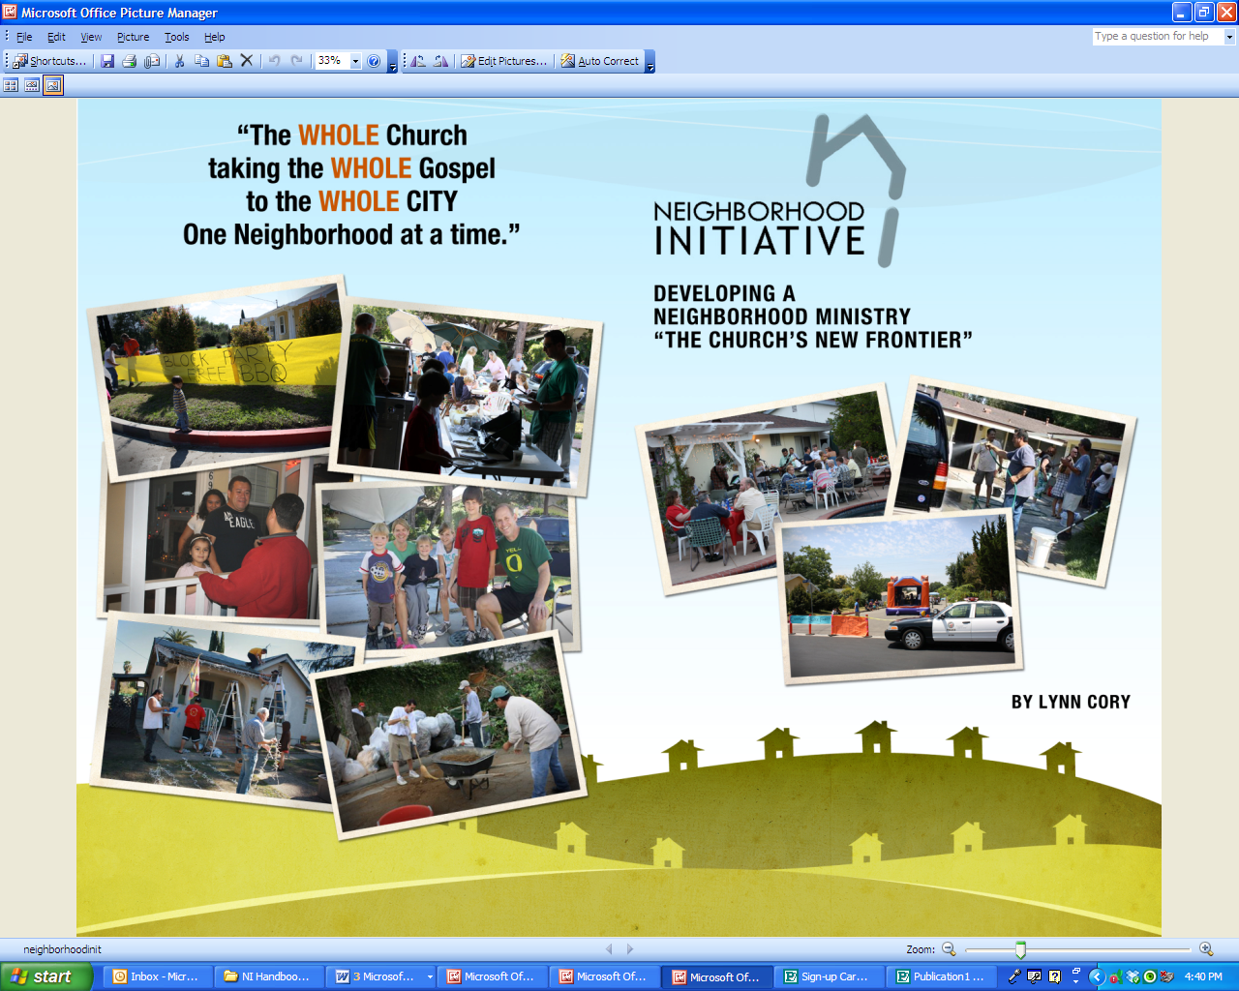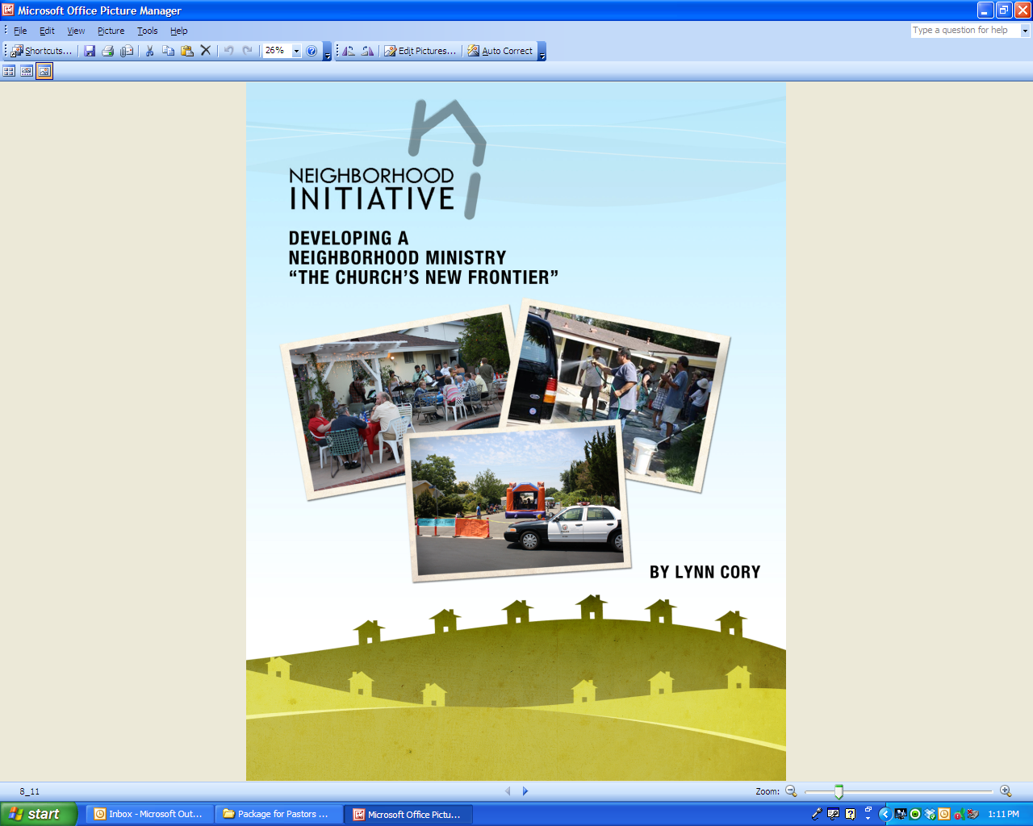

**Prayer Points for Neighborhood Ministry**

Jesus went through all the towns and villages, teaching in their synagogues, preaching the good news of the kingdom, and healing every disease and sickness. When he saw the crowds, he had compassion on them, because they were harassed and helpless, like sheep without a shepherd. Then he said to his disciples, "The harvest is plentiful, but the workers are few. Ask the Lord of the harvest, therefore, to send out workers into his harvest field."

* Pray to the Lord of the harvest to send laborers from the (*name of church*) out into our own neighborhoods.
* Ask the Lord to show you **a few** neighbors that He would like for you to develop relationships with in your neighborhood.
* Ask the Lord to give you eyes to see what is going on in each of their lives and then ask Him to give you a heart of compassion.
* Ask the Lord to show you what He is doing in each of your neighbor’s lives and how you can participate with Him in what He is doing.
* Ask the Lord to open doors for relationship with your neighbors, opportunities to serve and care for them, and to share with them your hope in Christ when they are receptive.

**Prayer Points for Neighborhood Ministry**

Jesus went through all the towns and villages, teaching in their synagogues, preaching the good news of the kingdom, and healing every disease and sickness. When he saw the crowds, he had compassion on them, because they were harassed and helpless, like sheep without a shepherd. Then he said to his disciples, "The harvest is plentiful, but the workers are few. Ask the Lord of the harvest, therefore, to send out workers into his harvest field."

* Pray to the Lord of the harvest to send laborers from the (*name of church*) out into our own neighborhoods.
* Ask the Lord to show you **a few** neighbors that He would like for you to develop relationships with in your neighborhood.
* Ask the Lord to give you eyes to see what is going on in each of their lives and then ask Him to give you a heart of compassion.
* Ask the Lord to show you what He is doing in each of your neighbor’s lives and how you can participate with Him in what He is doing.
* Ask the Lord to open doors for relationship with your neighbors, opportunities to serve and care for them, and to share with them your hope in Christ when they are receptive.

**Prayer Points for Neighborhood Ministry**

Jesus went through all the towns and villages, teaching in their synagogues, preaching the good news of the kingdom and healing every disease and sickness. When he saw the crowds, he had compassion on them, because they were harassed and helpless, like sheep without a shepherd. Then he said to his disciples, "The harvest is plentiful but the workers are few. Ask the Lord of the harvest, therefore, to send out workers into his harvest field."

Pray to the Lord of the harvest to send labors from the (name of church) out into our own neighborhoods.

Ask the Lord to show you **eight** neighbors that He would like for you to develop relationship with in your neighborhood.

Ask the Lord to give you eyes to see what is going on in each of their lives and then ask him to give you a heart of compassion.

Ask the Lord to show you what He is doing in each of your neighbor’s lives and how you can participate with Him in what He is doing.

Ask the Lord to open doors for relationship with your neighbors, opportunities to serve and care for them, and to share with them your hope in Christ when they are receptive.